GIORGIO ARMANI

Rimless round woman sunglasses

$ 330

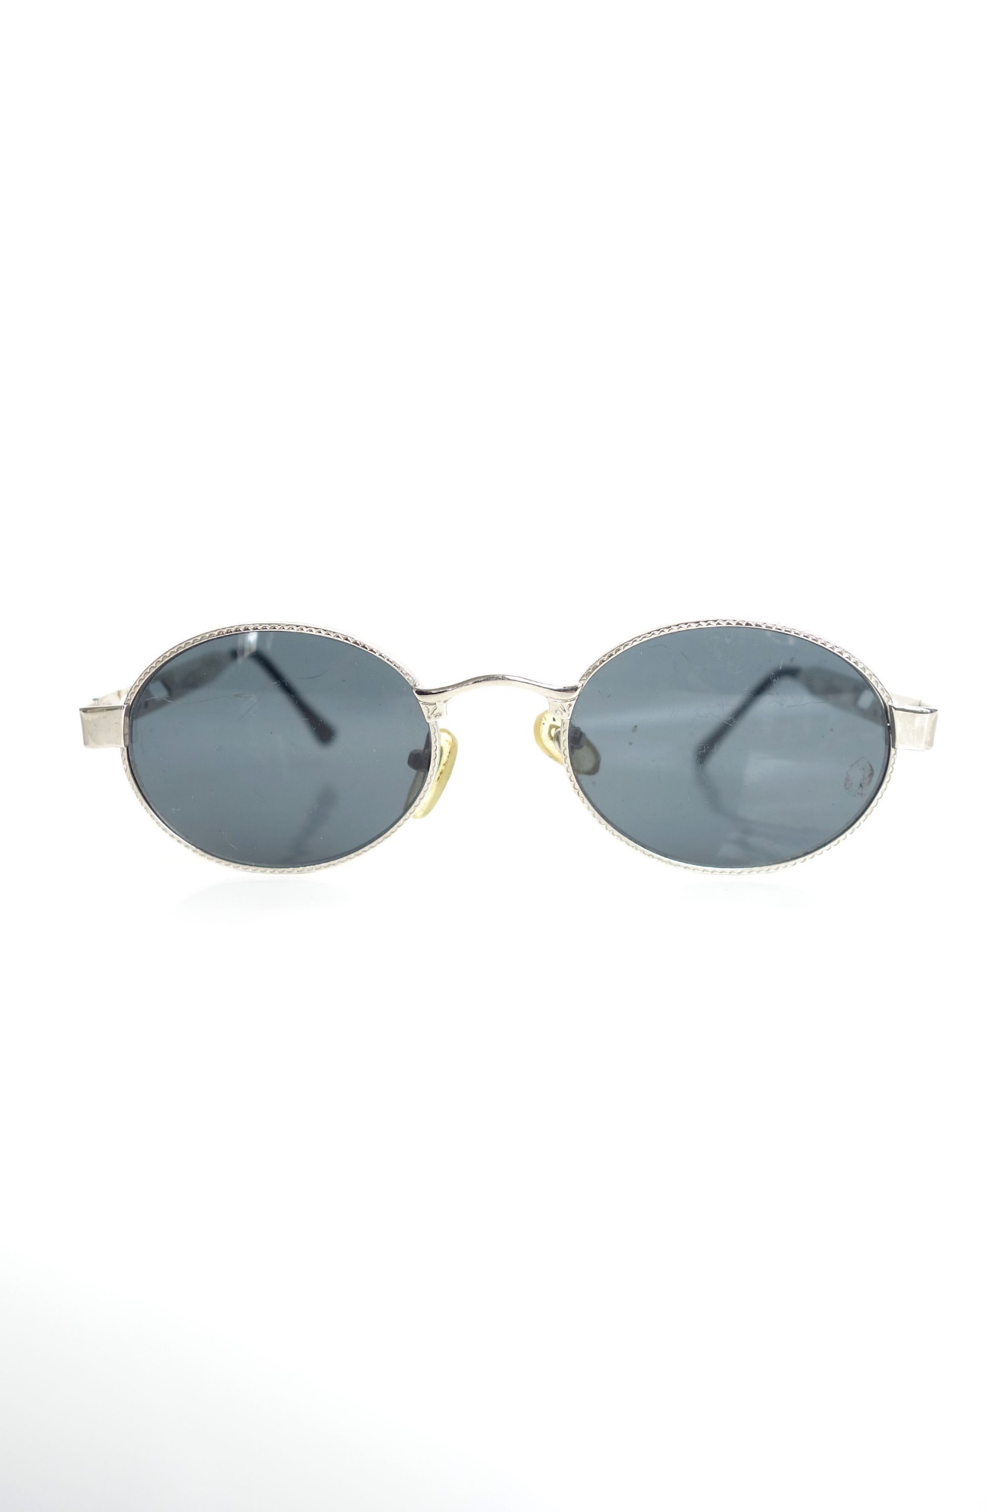
Details
Composition Metal
- Logo
- Metallic frame
- Tinted lenses

